To use G2C service –

Click on G2C services from menu bar and select any service.

Step-1
After lo0gin on E-district portal select the document you want to summit
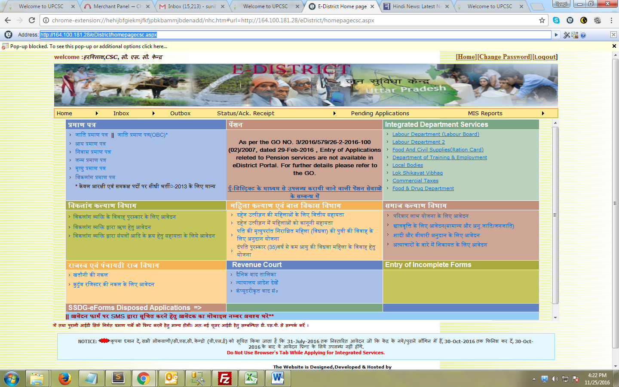

Step-2
Fill the complete form and click on Darge kare
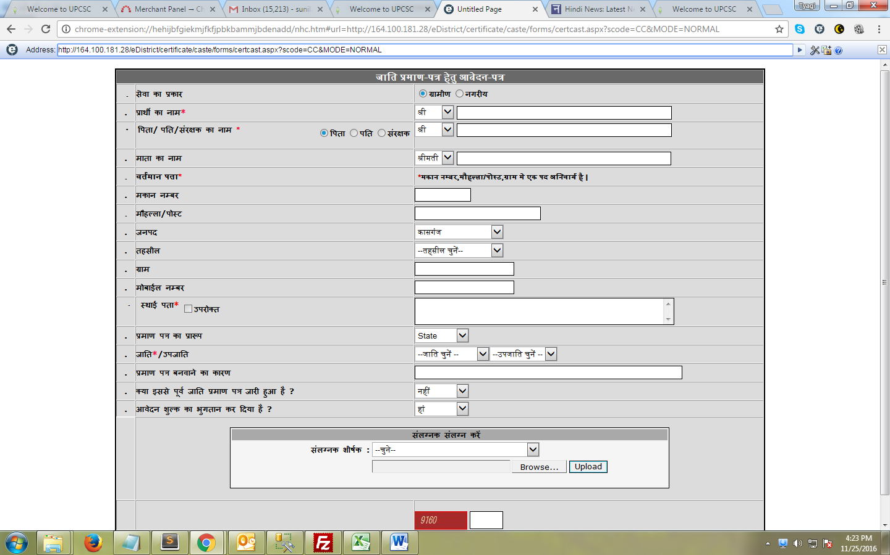
Step -4
Login on vayam portal for payment
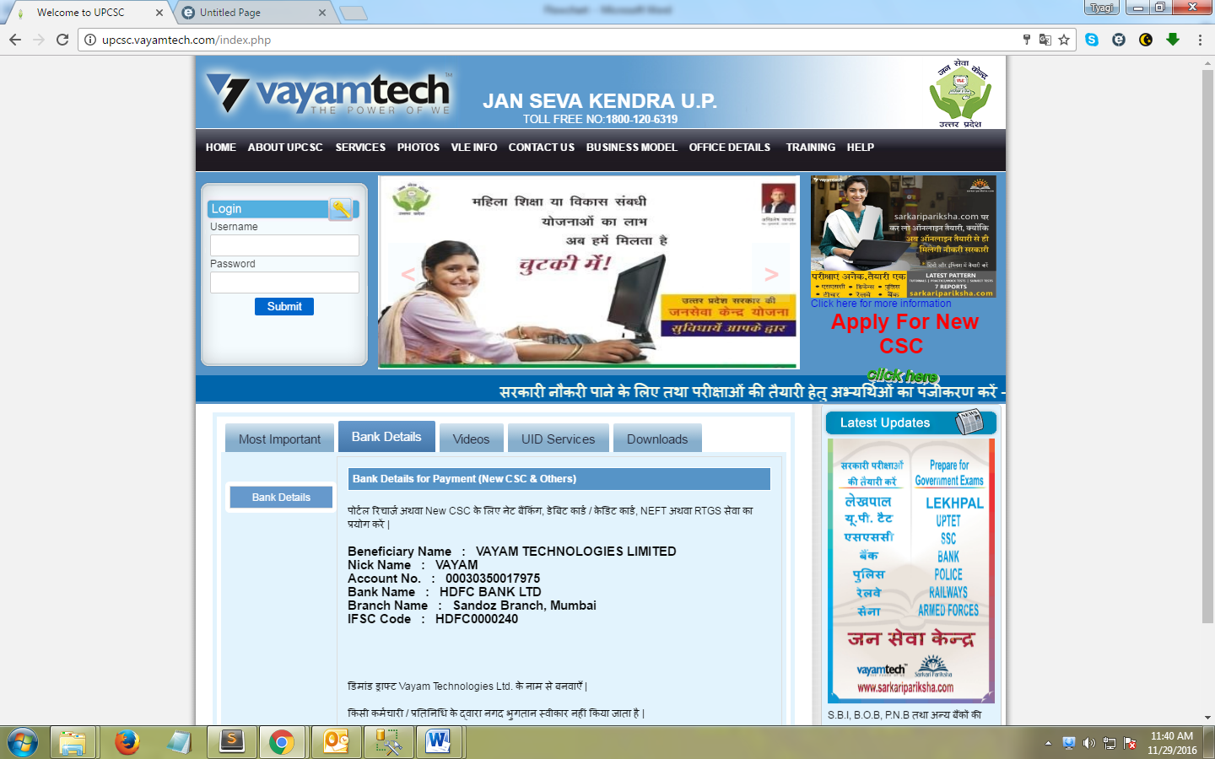
Step-5
After login re-enter the password

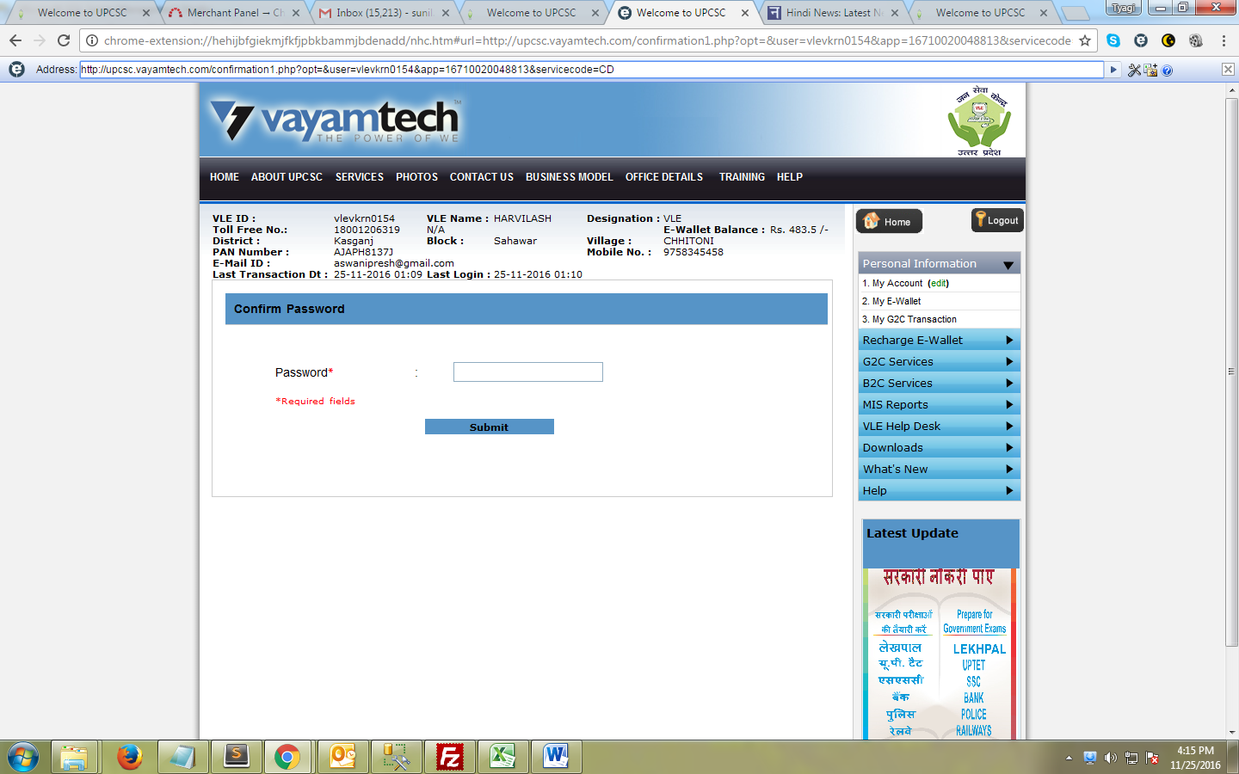
Step -6
Check the payment and Re-summit
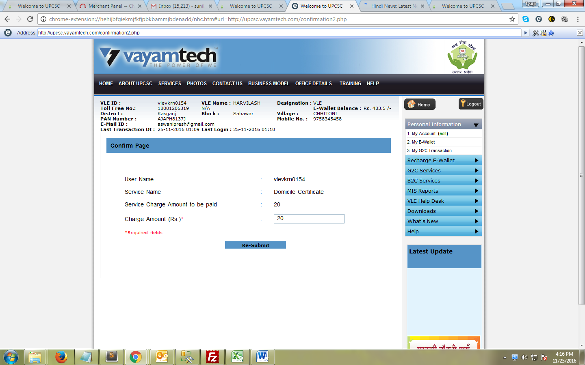
Step -7
Enter the captcha code and click on OK

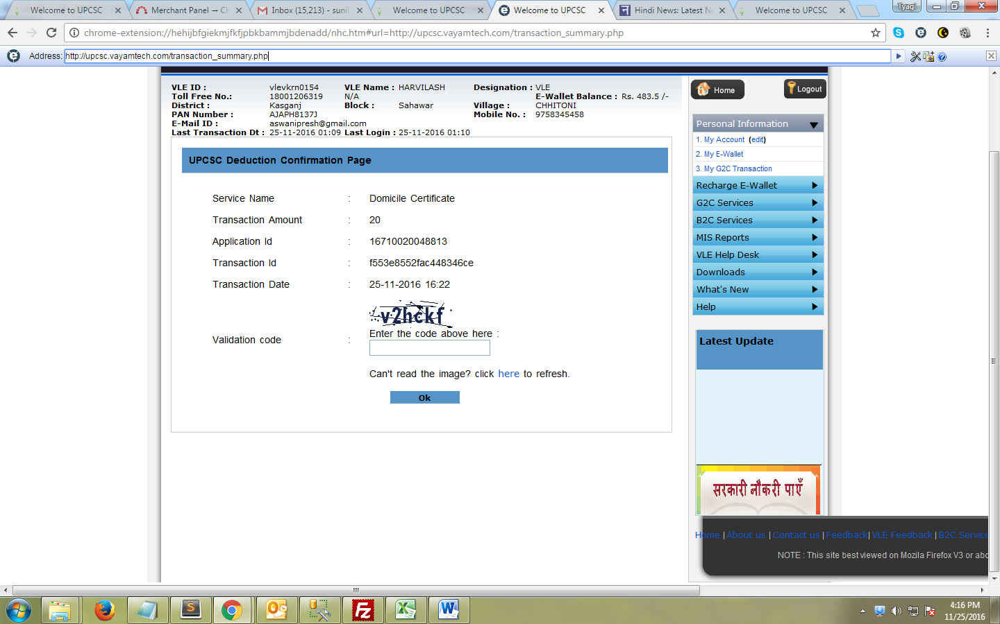
Step-8
Click on Proceed/ forward for authority approval
